Student Activity Manager

System Report

Table of Contents:

1. Executive Summary. 3

2. Design Analysis Process 3

3. Entity Relationship Diagram 3

4. Table Designs – Data Dictionary 3

5. Contributions. 3

6. References 4

1. Executive Summary

The Student Activity Manager System is a comprehensive system that aims to simplify and streamline student record management for educational institutions. This system provides a user-friendly interface that allows students, teachers, parents, and activity providers to access relevant information related to their respective roles. The system features several modules, including student management, course management, and scheduling, among others. The system also supports the management of extra-curricular activities, which allows schools to track and manage various activities offered to students outside the classroom. The proposed system offers a range of features and functionalities that can significantly reduce the administrative burden on educational institutions and improve the overall efficiency and effectiveness of their operations.

An activity manager system can provide many benefits to parent users by helping them stay organized, save time, and communicate more efficiently.

1. Design Analysis Process

## Software Development Life Cycle

The Student Activity Manager system was being built with Agile Method of Software Development Life Cycle. The agile SDLC is ideal for this system with changing requirements, where collaboration and feedback are critical, and where the end-users' involvement is essential. The agile approach emphasizes flexibility, continuous improvement, and rapid delivery of working software.

## Business Case

Student Activity Manager is an efficient and effective solution for managing student records, scheduling classes and extra-curricular activities, and viewing enrolments to courses and activities. By implementing this system, the institution can streamline administrative tasks, reduce errors and redundancies, improve communication between stakeholders, and ultimately enhance the educational experience for students, parent and teachers.

The system would also provide valuable insights to improve outcomes, such as optimizing course/activities offerings and schedules, and ensuring compliance with regulations and policies.

In addition, the system can help to enhance the institution's reputation and competitiveness, as it demonstrates a commitment to modernizing and innovating its operations, which can attract and retain students, faculty, and staff. Ultimately, the business case for this system is to improve efficiency, effectiveness, and student outcomes, while also contributing to the overall success of the educational institution.

An activity manager system can provide several benefits to parent users.

Efficient scheduling: help parents schedule activities and appointments for their children in an organized manner. With an activity manager system, parents can easily view their child's activities and schedules for the week or month, helping them plan their own schedules accordingly.

Time-saving: By using an activity manager system, parents can save time by not having to keep track of their child's activities and appointments manually. This can free up time for parents to focus on other tasks, such as work or household responsibilities.

Easy communication: An activity manager system can provide an easy way for parents to communicate with their child's teachers, coaches, and other activity leaders. This can help parents stay up-to-date with their child's progress and any changes or updates to their schedule.

Increased organization: An activity manager system can help parents stay organized by keeping all of their child's activities and appointments in one place. This can help prevent double bookings or missed appointments.

Better coordination: An activity manager system can help parents coordinate activities and schedules with other family members or caregivers. This can help ensure that everyone is on the same page and can plan their schedules accordingly.

## User Cases

### Use cases for students:

* 1. View their personal information (name, email, phone, address, etc.)
  2. View their academic enrolment.
  3. View available courses.
  4. View their course schedule.
  5. View their after-school activity schedule.
  6. View their extracurricular activity participation.
  7. Search for other available activities that may be interested.

### Use cases for teachers or instructors: ?????Provider or School? No entities called teachers or instructors

* 1. View and manage their courses (create, modify, or delete course details)
  2. View and manage their course enrolments.
  3. View and manage their students (access their personal information, communicate with them via email, class schedule.)
  4. View and manage extracurricular activities.
  5. View student’s parents’ information.

### Use cases for parents or guardians:

* 1. View their children's personal information (name, email, phone, address, etc.)
  2. View and manage their children's course enrolments.
  3. View their children’s schedule.
  4. View and manage their children's after-school activity participation.
  5. View the courses and after-school activities teachers or instructors.
  6. View transportation details of activities.

## User Stories

* + a working mother of two children who are involved in various extracurricular activities. She uses the Activity Manager system to stay informed about upcoming events, practices, and games. She can also communicate with activity leaders or coaches through the platform, ask questions, and receive updates. This helps the mother manage her busy schedule more effectively and ensure that her children never miss an important activity.
* A family has two children who are involved in various extracurricular activities, and both parents work full-time. They use the Activity Manager system to coordinate their family schedule and ensure that everyone is on the same page. For example, they use the system to view their children's activity schedules, coordinate transportation, and communicate with activity leaders or coaches. This helps the Smiths manage their busy family schedule more effectively and ensure that no one misses an important activity. Additionally, the system allows the Smiths to stay informed about their children's progress and activities, so they can be more involved in their children's lives.
* A high school student who is involved in multiple extracurricular activities, including sports, music, and community service. She wants to manage her time effectively to balance her academic work and extracurricular activities. She uses the Activity Manager system to have an overview of her schedule.
* A music teacher who offers private lessons to students of all ages. She needs to view her students' schedules, which helps her manage her own schedule and avoid scheduling conflicts. When she logs into the system, she can view each student's schedule, including their academic classes, extracurricular activities, and other commitments. This allows her to schedule lessons at a time that works for both her and the student, without conflicting with other activities.
* A school is a large public school with many extracurricular activities available to students. They need to manage their extracurricular programs, including sports teams, music ensembles, and clubs. When a student signs up for an extracurricular activity, the system automatically updates their schedule to reflect the commitment. This allows students, parents, and teachers to easily see when a student is occupied with an extracurricular activity and when they are available for academic classes. School can efficiently manage their extracurricular programs and ensure that students have access to a wide range of activities that support their academic and personal growth.

## Use Case Diagram

## Functional And Non-Functional Requirements:

### Functional Requirements:

* Ability to store and manage student information, including personal details, academic courses and activities, and schedules.
* Ability to schedule classes and register students for classes.
* Ability to create and manage student and parent profiles, including their contact information.
* Ability to manage after-school activities and its instructors.
* Ability to provide a user-friendly interface for all system users.

### Non-Functional Requirements:

* **Security**: The system would be designed to be secure, with appropriate measures in place to prevent unauthorized access and protect the privacy of student and educator information.
* **Reliability:** The system would be always reliable and available, with minimal downtime or service interruptions.
* **Performance:** The system would be able to handle a large number of users and data volumes without performance issues.
* **Scalability**: The system would be scalable to support future growth and changing needs.
* **Usability:** The system would be easy to use and navigate for all users, with intuitive interfaces and clear documentation.
* **Accessibility**: The system would be accessible to all users.
* **Compatibility:** The system would be compatible with various devices, platforms.
* **Maintainability**: The system would be easy to maintain and update, with well-documented code.

## Actors

* + **Parents or guardians: parents or guardians would be the primary users of the system, they could view their child's schedule, sign them up for activities, and receive notifications about upcoming events or changes to schedules. Contribute to their time management and family members’ coordination.**
  + **Students: they would use it to sign up for extracurricular activities, view their schedules, and track their attendance and progress in these activities.**
  + **Activity providers: would use the system to view their students' schedules, track attendance and progress, and communicate with students and parents about upcoming events or changes to schedules.**
  + **Institution administrators: school or institution administrators would use the system to manage and oversee extracurricular programs.**
  + **Teachers or academic advisors: teachers or academic advisors would use the system to view students' schedules and ensure that academic classes are scheduled around extracurricular activities, and to monitor attendance and progress in extracurricular activities as part of their overall support for student success.**

## Events

### Internal Events

* New student enrolment
* Updating Student information
* Faculty or staff changes (new hires, resignations, etc.)
* Enrolment of a student
* Updating of student information
* Addition or removal of an instructor

### External Events

### Temporal Events

1. Entity Relationship Diagram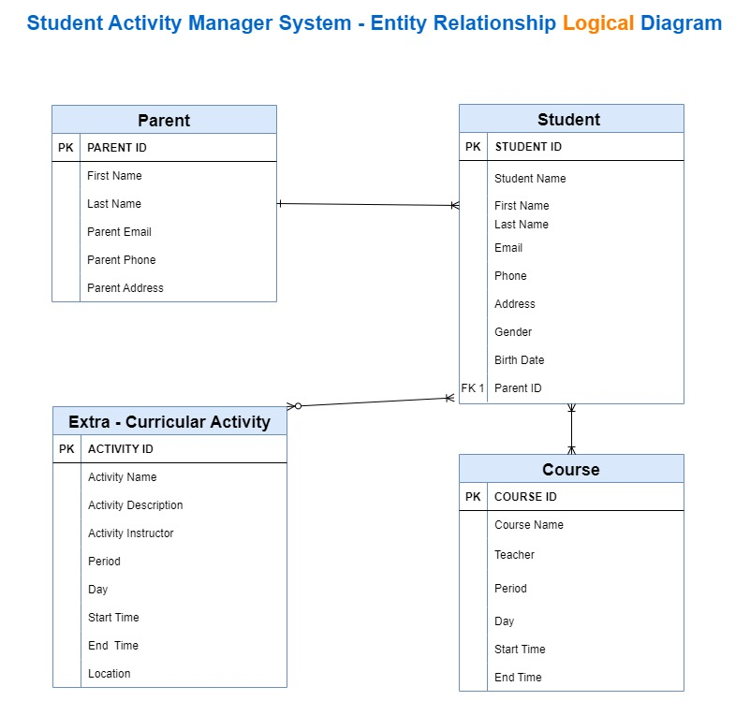

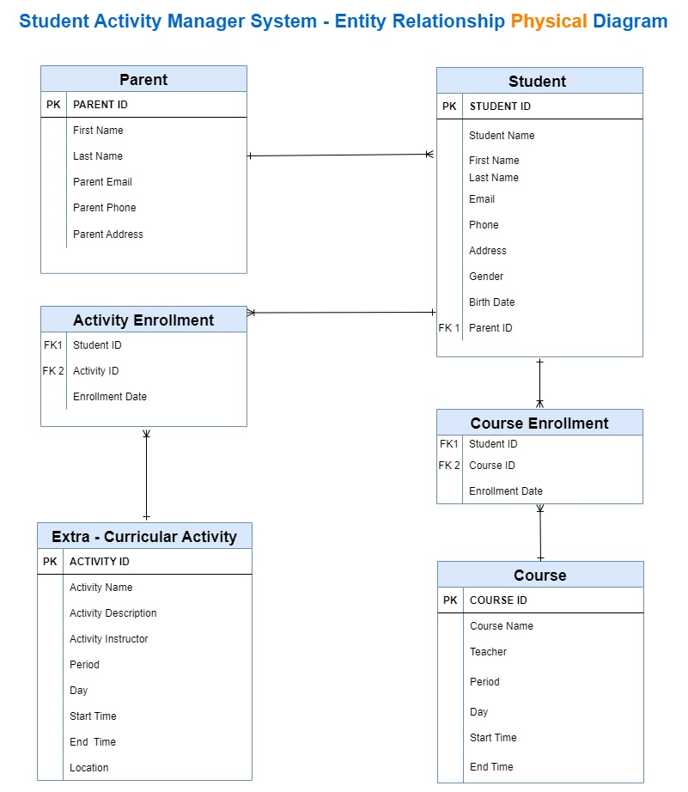

1. Table Designs – Data Dictionary

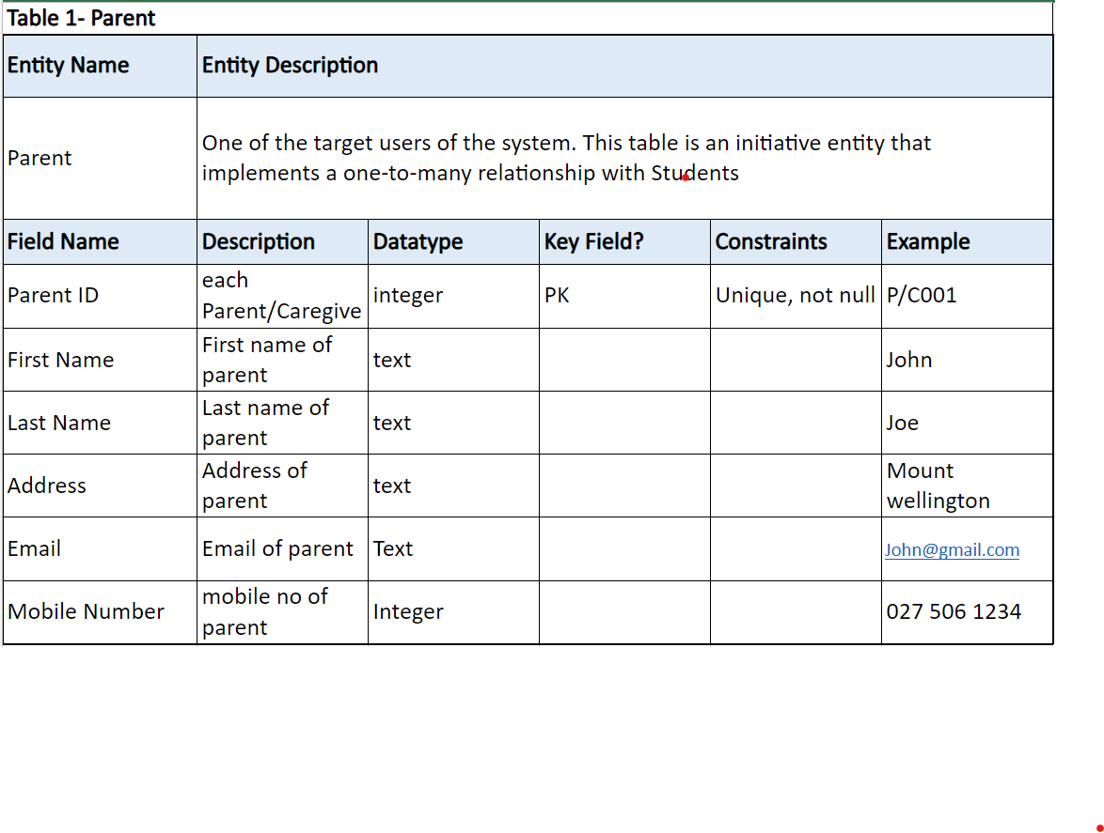

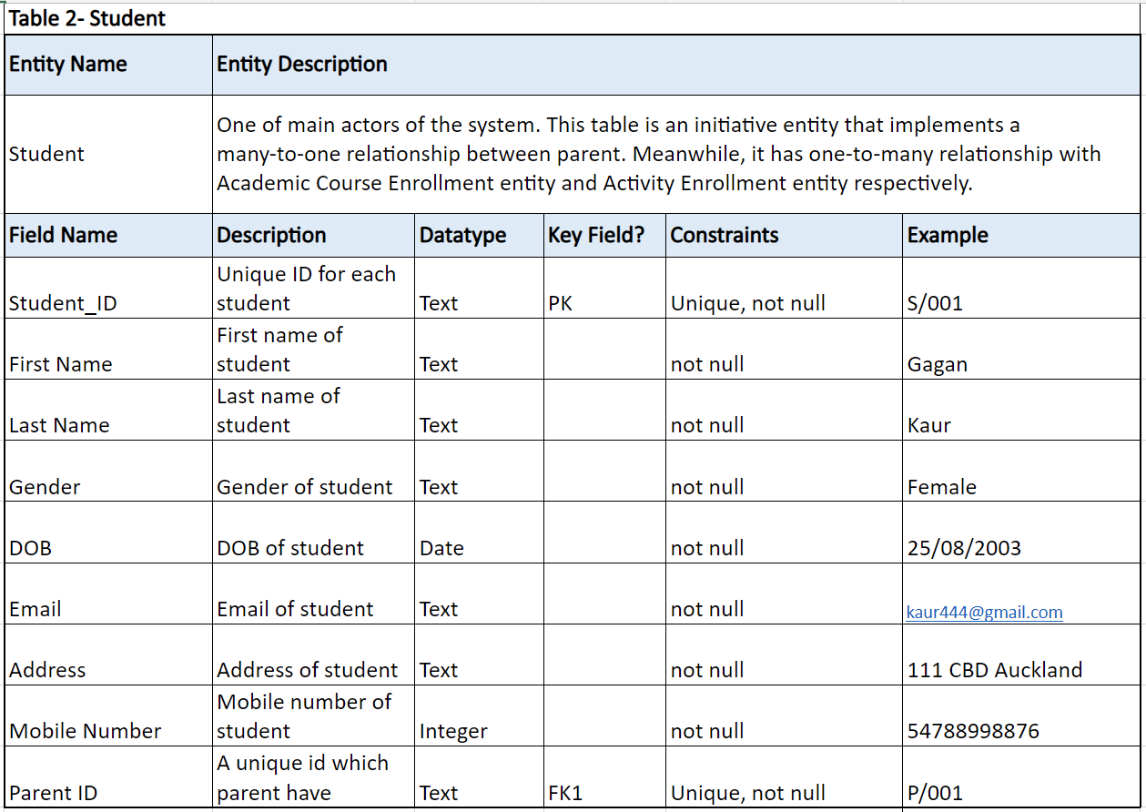

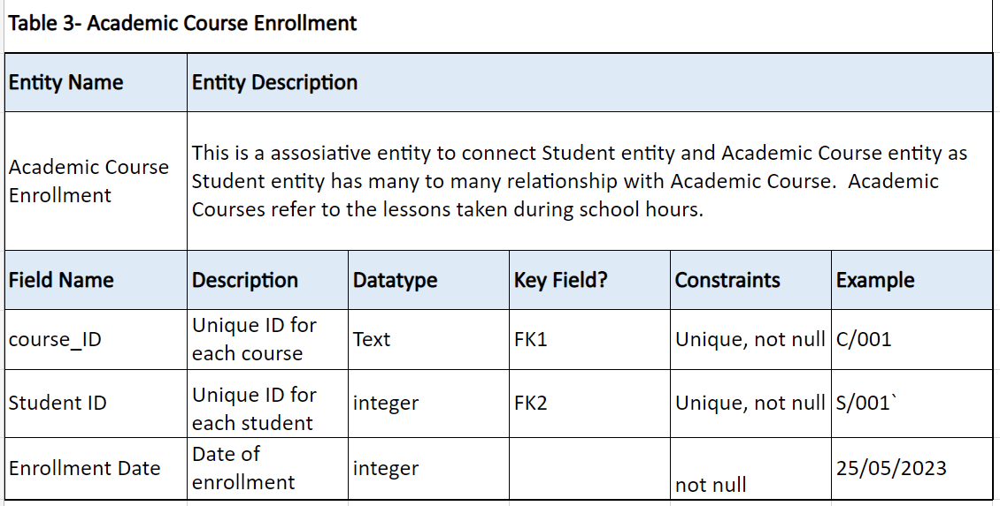

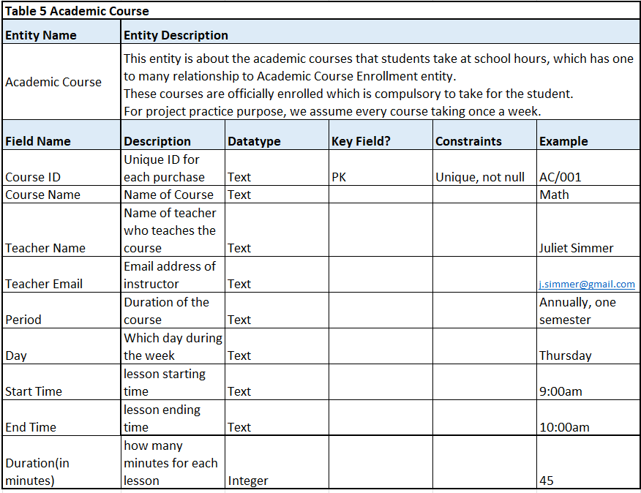

1. Contributions

## Harshil Dholakiya

## Liman Wu

## Arshdeep Singh

## Gagandeep Kaur

1. References

## student Record Management Systems: Definition, Benefits, and Top Tools:

<https://www.slideshare.net/JulietNandutu/student-record-management-system-1-63051646>